Lab manual 21-30
Experiment 21:
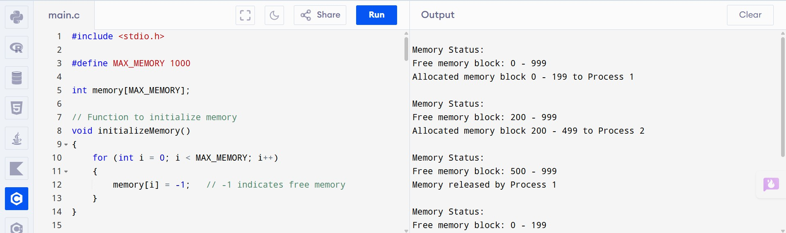

Experiment 22:
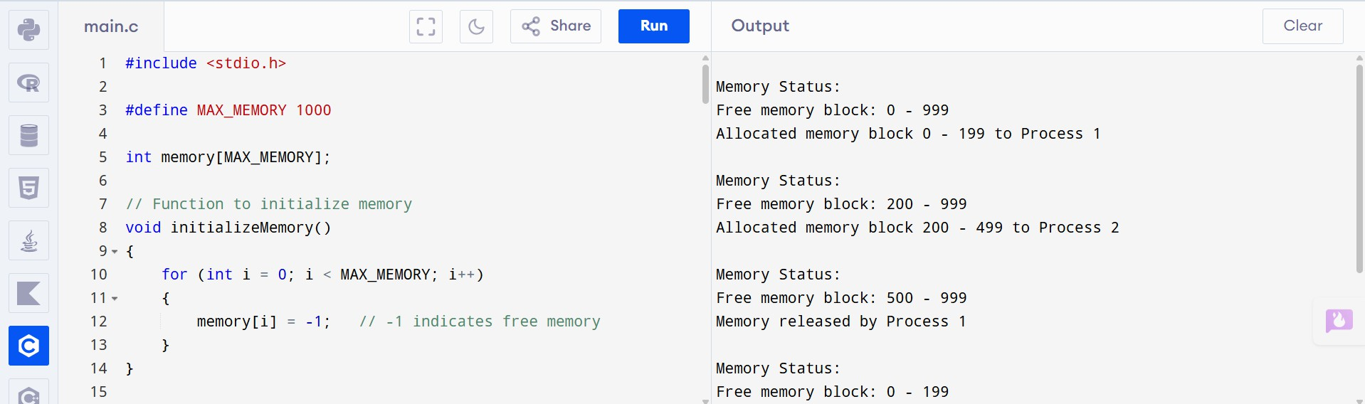

Experiment 23:
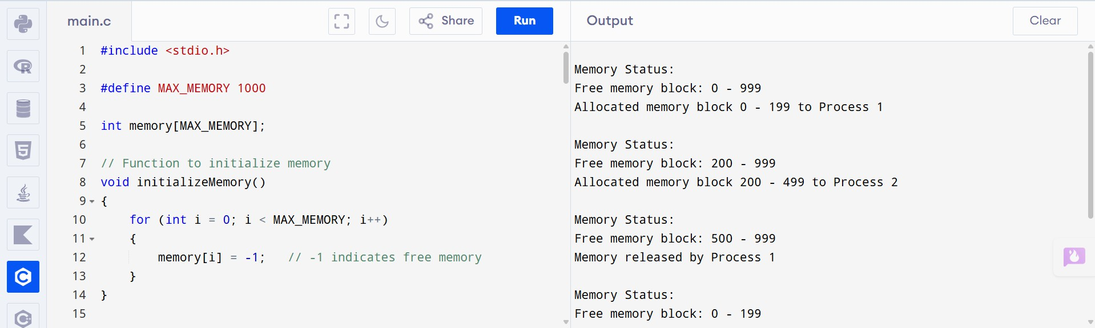

Experiment 24:
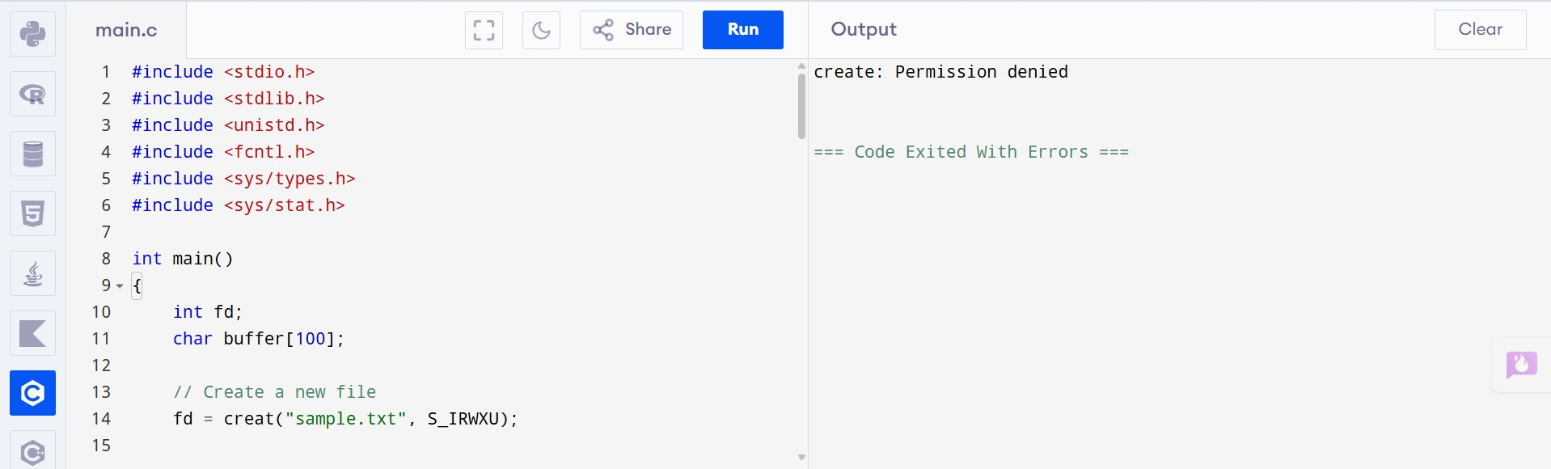

Experiment 25:
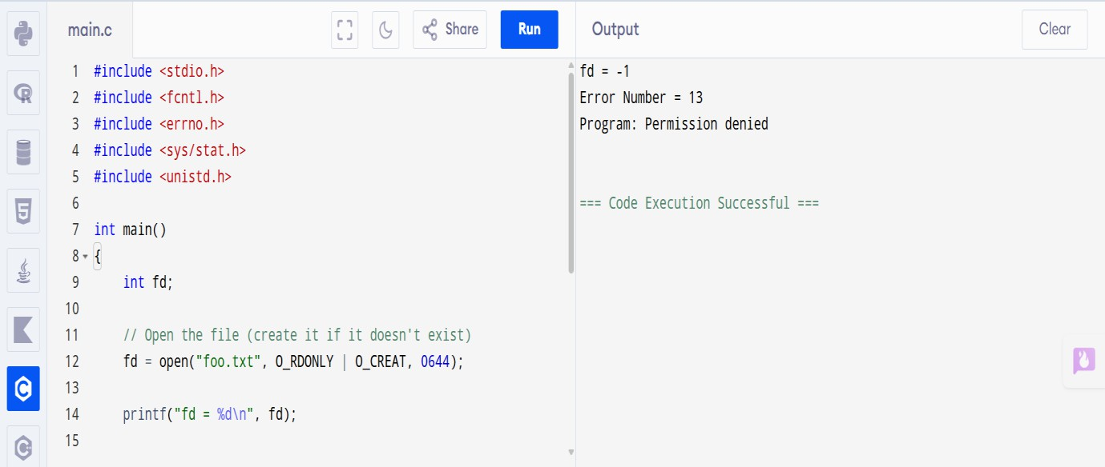

Experiment 26:
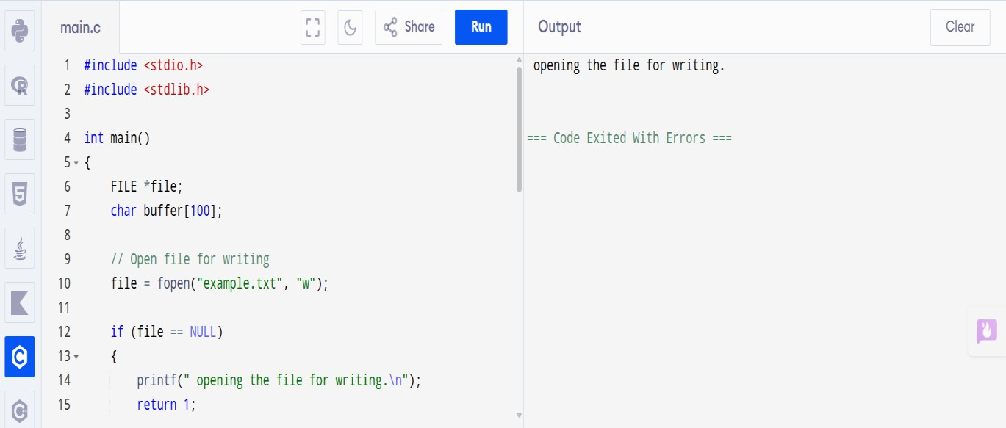

Experiment 27:
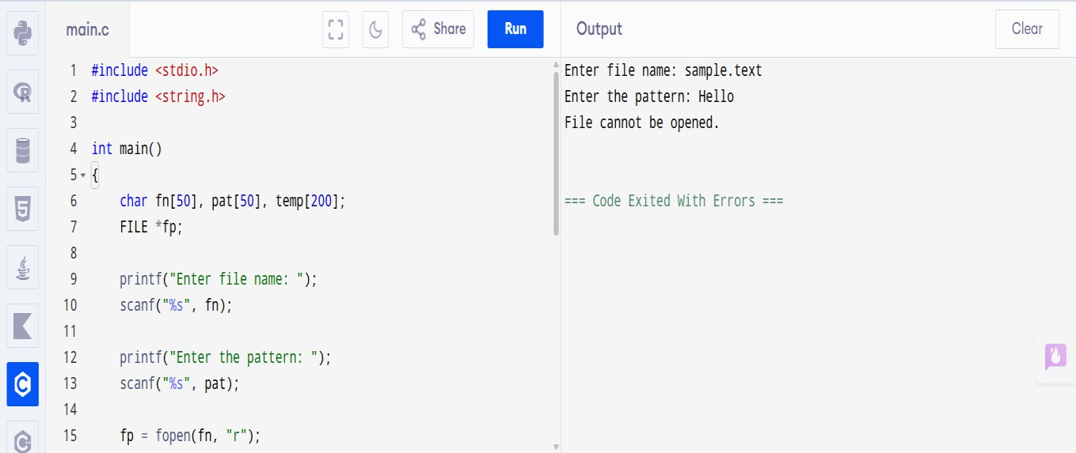

Experiment 28:
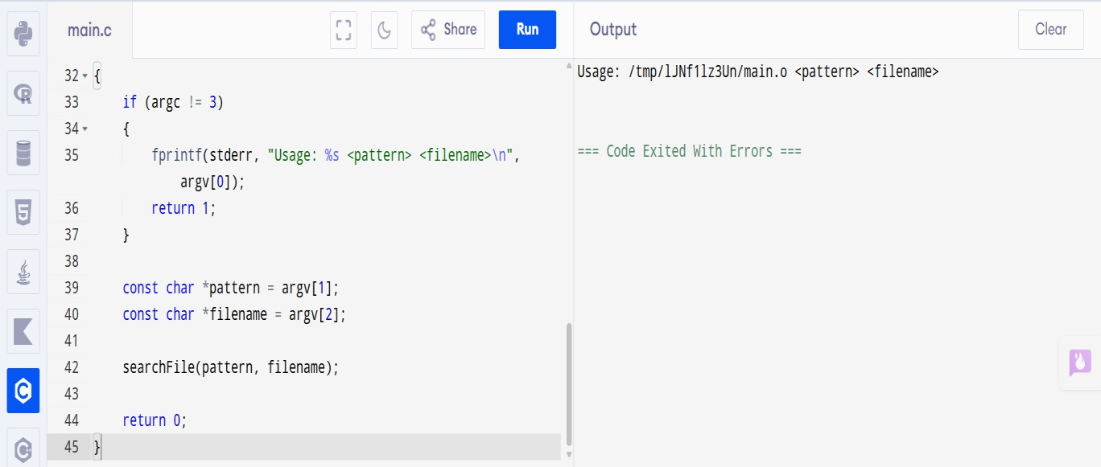

Experiment 29:
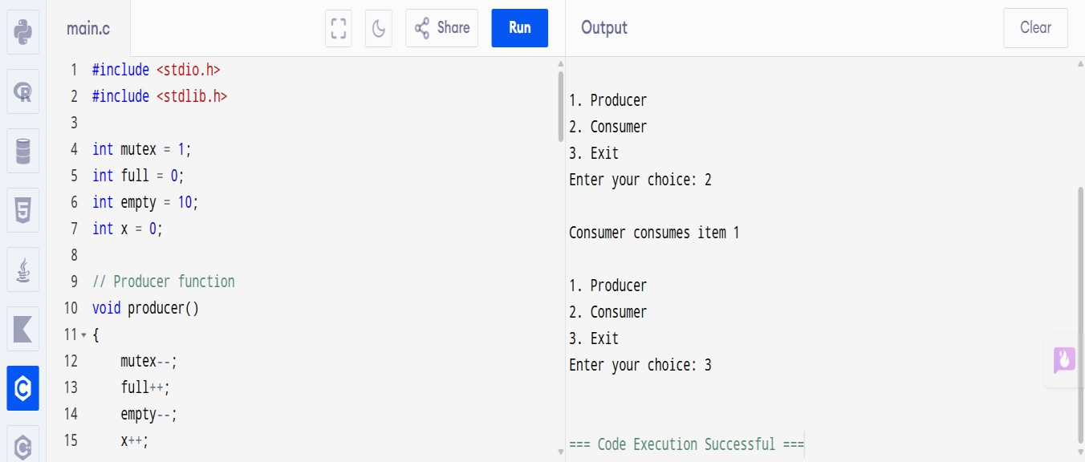

Experiment 30:
